# Part B

## Pre-processing

The pre-processing method chosen was to centre and upscale the bitmap. This has the effect of standardising letters, as all images including small and/or off-centre images will appear similar and so be identified easier. This process of making the image to be classified as uniform as possible is a key aspect of any pattern recognition process [1]. The limitations of this pre-processor are that it is relatively simple and scales the image from the first detected pixel in each direction. As such a noisy image will be scaled to the most outward pixel whether it is useful data or noise.

This pre-processor was implemented using existing Java image libraries.

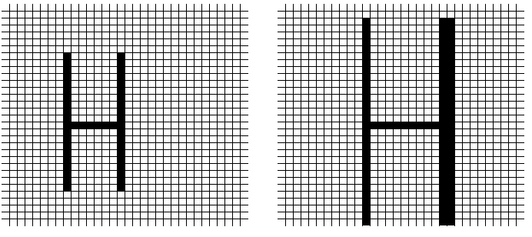

Figure : an image being centred and up-scaled.

The pre-processor showed a marked increase in accuracy, averaging a 15.98% increase compared to the default classifier for a given sample size. Due to the extra overhead this did however cause a noticeable increase in time for both training and evaluation, with the increase in time being proportional to the number of images.

Figure

Figure

The data used in the charts above was acquired from a single-layer neural network using a 65%/35% training/testing data split and a 0.12 eta value. These are the optimal values discovered previously for this type of classifier, with the data split resulting in 2994 images used for training and 1612 used for evaluation.

It can be seen how effective the pre-processing is on an equivalent sample size. It can also be seen that there is a flat overhead of ~4.07s for the pre-processor. From the testing sample size of 2994 images this indicates each image takes approximately 0.001358s to process on the machine used for testing.

Figure 2 shows how accurate the classifier is with certain sample sizes. This is a good indication of how effectively it has been able to learn at a given point, and demonstrates a diminishing return after approximately 50 000 samples for both variants.

Bibliography

[1] Jawad H AlKhateeb, Jinchang Ren, Jianmin Jiang, Husni Al-Muhtaseb, Offline handwritten Arabic cursive text recognition using Hidden Markov Models and re-ranking, Pattern Recognition Letters, Volume 32, Issue 8, 1 June 2011, Pages 1081-1088, ISSN 0167-8655, http://dx.doi.org/10.1016/j.patrec.2011.02.006.

(http://www.sciencedirect.com/science/article/pii/S0167865511000432)